**Prometheus**

From the very first, humans had trouble with the gods. Most gods thought of humans as toys. But some gods found themselves interested in the human race. Some gods even made friends with the humans. One of those gods was named Prometheus.

The first people created by the gods lived happily together. They thought the gods were wonderful. But their children were not as grateful or as content. The children argued among themselves, and sometimes even argued with the gods.

Zeus was very disappointed at mankind. He decided he was not going to give mankind a most important tool - fire! Without fire, humans were not going to last very long.

Prometheus felt sorry for his human friends. Fire was important for many things - like heat and cooking, and hundreds of others. Prometheus stole a lightning bolt from Zeus and gave it to mankind. That's when man discovered fire.

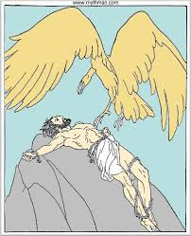Zeus was furious. He ordered Prometheus chained to a rock as punishment for stealing his lightning bolt, and for going behind his back to help the humans. To make Prometheus even more miserable, Zeus sent storms to beat angry waves against  Prometheus, helplessly chained to his rock. Zeus made the sun shine really brightly now and then to burn his skin. Zeus even sent an eagle to nibble at poor Prometheus' body. It was quite a punishment for a god who had only tried to help mankind. But he had defied Zeus, and that was what made Zeus so angry.

It was [Hercules](http://greece.mrdonn.org/greekgods/hercules.html) who finally released the helpless god from his chains. By the time Hercules saved him, nearly a thousand years had passed. That's probably not a lot of time if you happen to be immortal. But humans had changed a great deal over 1000 years. By then, Zeus found humans quite entertaining. Zeus no longer cared if anyone rescued Prometheus or not.

http://greece.mrdonn.org/greekgods/prometheus.html