Name _________________________ Period _________

Racing in The Rain

Chapters 9-15

After reading chapters 12-15, answer the following comprehension questions below. Look back in your book for evidence.

1. Why is Enzo left alone?

____________________________________________________________________________________________________________________________________________________________________________________________________________________________________________________________________________________________________________

2. What is the subject analyzed in Chapter ten?

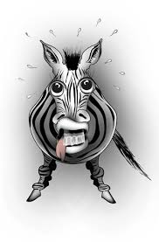

______________________________________________________________________________________________________________________________________________________________________________________________________________________________________________________________________________________________________

___________________________________________________________________________________________________________________________________________________

3. Zoes’s zebra comes alive and threatens Enzo. What does the zebra symbolize.

____________________________________________________________________________________________________________________________________________________________________________________________________________________________________________________________________________________________________________

4. What does Denny do to Enzo that is unexpected?

____________________________________________________________________________________________________________________________________________________________________________________________________________________________________________________________________________________________________________

5. How have Eve and Denny changed from the beginning of the book?

____________________________________________________________________________________________________________________________________________________________________________________________________________________________________________________________________________________________________________

6. Why won’t Zoe eat her chicken nuggets?

____________________________________________________________________________________________________________________________________________________________________________________________________________________________________________________________________________________________________________