Pop Bottle Heroes

1. Bottle buddies are bottles that are emptied and cleaned. They are then decorated to look like your famous Greek. You can add yarn for hair, eyebrows, and mustache. The bottom of the bottles can be just plain, or you can add shoes/feet.

Here are some suggested items you may want to use to help you:

* 1 plastic bottle (medium-sized dish detergent bottle or large soda bottles)
* 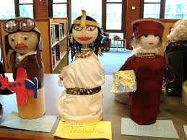1 Styrofoam ball or large wooden bead for head (a dolls head also works)
* scrap fabric for clothes
* wiggle eyes (optional)
* dirt, stones, or sand to fill 1/4 of bottle
* yarn/string/ fake hair
* paint
* glue
* scissors

2. Clean and thoroughly dry the plastic bottle.

3. Fill 1/4 of the bottle with dirt or sand to stabilize it.

4. Place Styrofoam ball or wooden bead on top of bottle to form head. Decorate the "head" to represent the hero and glue it to the body.

5. Construct arms for the bottle person by using pipe cleaners, cardboard, or other items and fix (glue) them in place.

6. Use scrap fabric to construct an outfit for the bottle person that represents what they might have worn.

7. You can add symbols or other things that the hero might have used.